Project Design Report: HematoVision

Date | 15 January 2026
Team ID | LTVIP2026TMIDS38170
Project Name | Hematovision: advanced blood cell classification using transfer learning
Maximum Marks | 4 Marks

Introduction
This document outlines the design phase of the HematoVision project, focusing on the Data Flow
Diagrams (DFDs) and User Stories. These elements are crucial for understanding the system's functional requirements and the flow of information within the application. This report is based on the provided DataFlowDiagramsandUserStories.docx file.

Data Flow Diagrams (DFDs)
A Data Flow Diagram (DFD) visually represents the information flows within a system. It illustrates how data enters and leaves the system, what processes transform the information, and where data is stored. DFDs are essential for graphically depicting system requirements in a clear and concise manner.
The provided document includes examples of DFDs, demonstrating the visual approach to understanding system interactions. While specific DFDs for HematoVision are not detailed in the text, the inclusion of this section indicates the importance of visualizing data movement for the project.

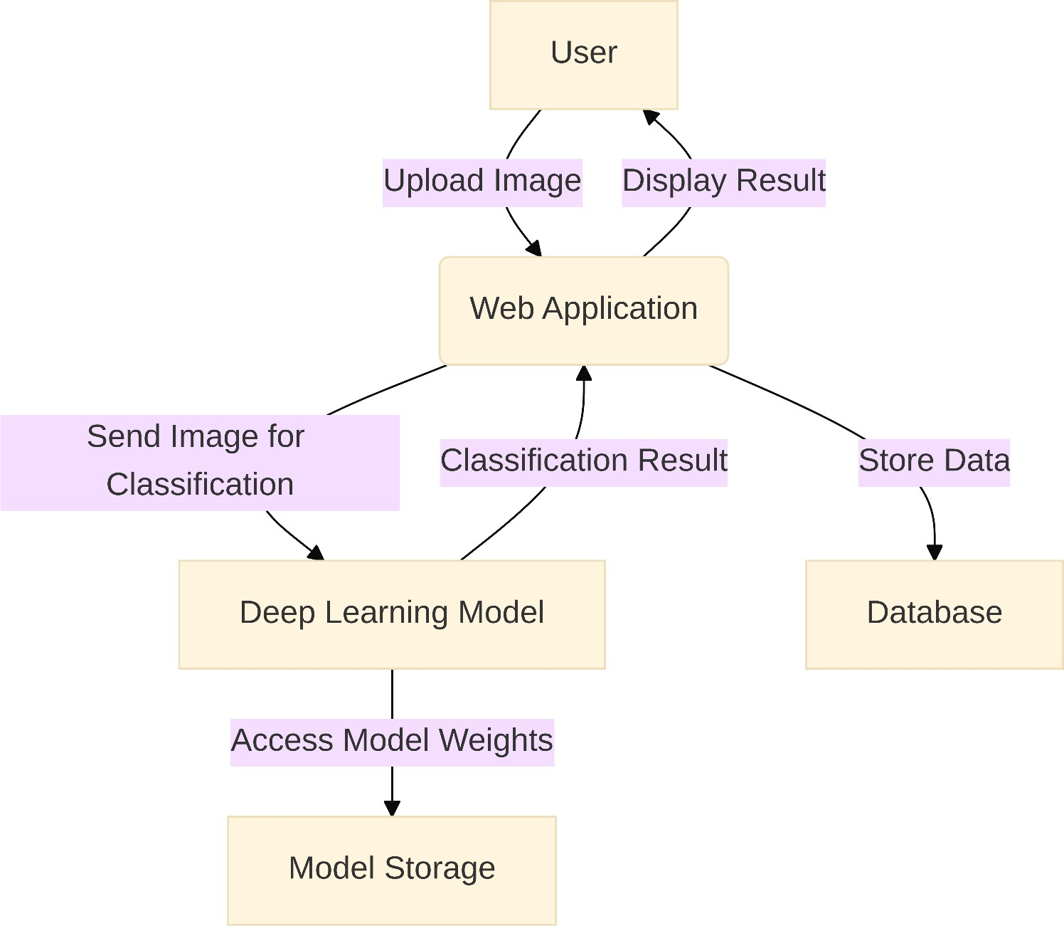

User Stories
User stories are short, simple descriptions of a feature told from the perspective of the person who
desires the new capability, usually a user or customer of the system. They are a key component of agile software development, helping to define the scope and functionality of the application from a user- centric viewpoint.
The document provides a template for listing user stories, categorized by User Type , 
Functional Requirement (Epic) , User Story Number , User Story / Task , Acceptance criteria , Priority , and Release .

Detailed User Stories for HematoVision
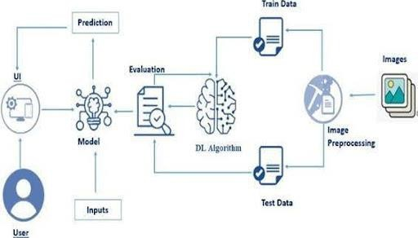s

The following user stories are extracted from the provided document, primarily focusing on

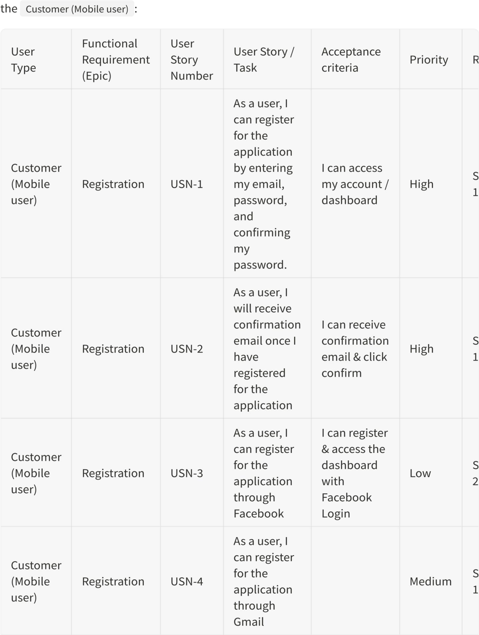

Analysis of User Stories:

- Registration: The initial focus is on user registration, with high-priority tasks for emailbased registration and confirmation. Social media logins (Facebook, Gmail) are also considered, with Gmail
registration being a medium priority for Sprint-1 and Facebook a lower priority for Sprint-2.

- Login: A high-priority user story ensures that users can log into the application using their email and password.

- Dashboard: While a functional requirement for the dashboard is listed, no specific user stories are provided for it in the given extract. This suggests that the dashboard functionalities would be
detailed in subsequent user stories or design documents.

Other User Types
The template also lists other user types such as Customer (Web user) , Customer Care Executive , and
Administrator . Although no specific user stories are provided for these roles in the extracted content,
their inclusion indicates that the HematoVision project is designed to cater to a diverse set of users with different access levels and functionalities.

Conclusion
The design phase of HematoVision, as evidenced by the Data Flow Diagram concepts and detailed User
Stories, emphasizes a user-centric approach to development. The clear articulation of user requirements, particularly for mobile users, provides a solid foundation for the development sprints. The structured approach to defining functional requirements and acceptance criteria will be instrumental in guiding the development team and ensuring that the final product meets the intended user needs.

